**Assignment ( PowerBI ):- 01**

* **Install Power BI Desktop and share the final screenshot of the report view page which appears when power desktop starts.**

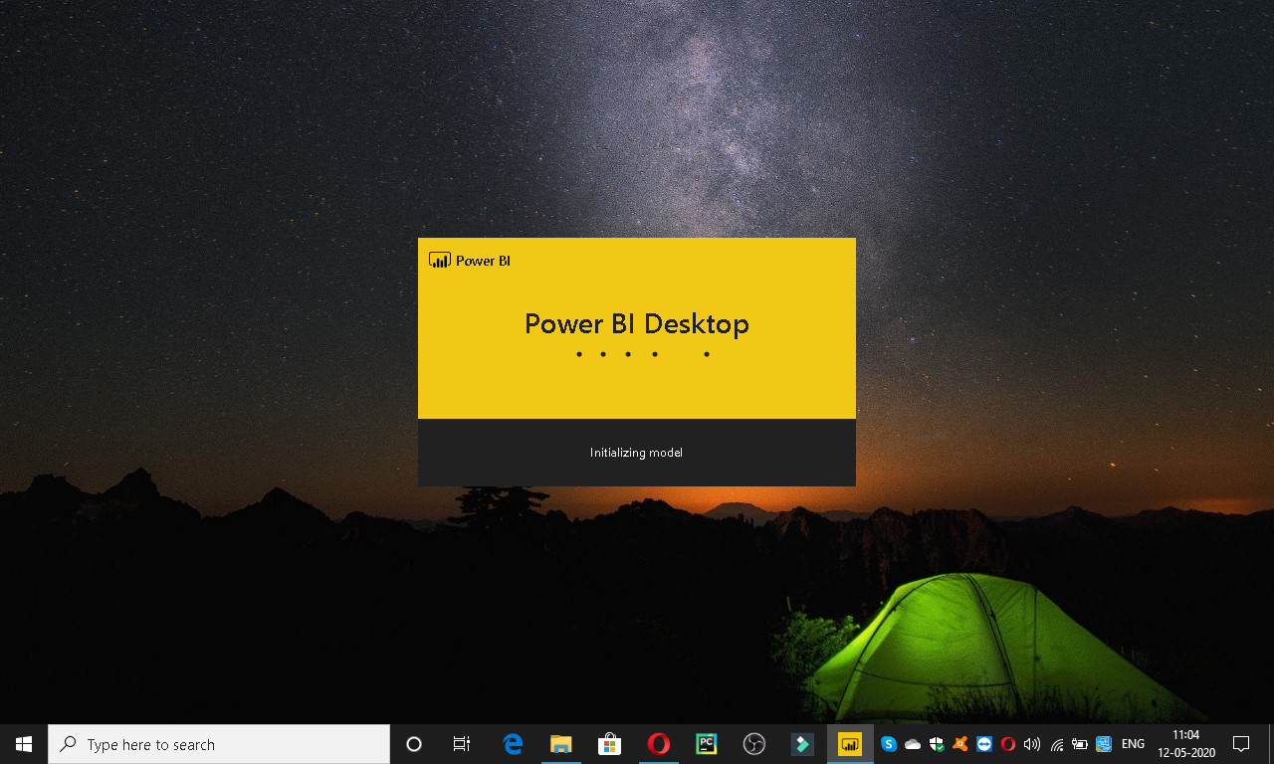

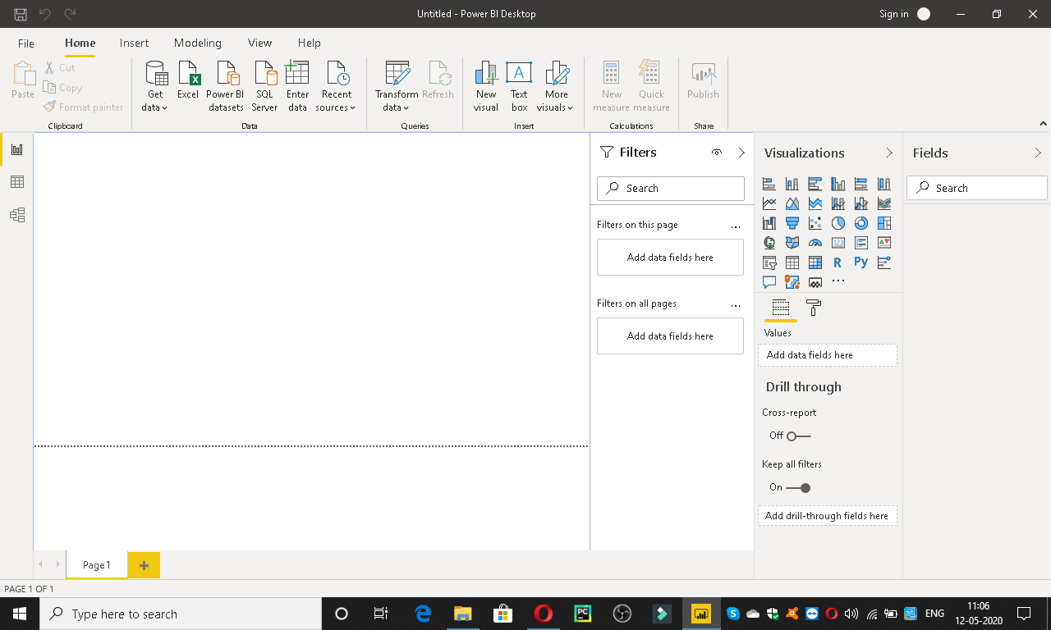

* **Prepare a document and with the following screenshot**

**( Report View − Data View − Model View − Power Query Editor − Advance Editor )**

**ReportView**

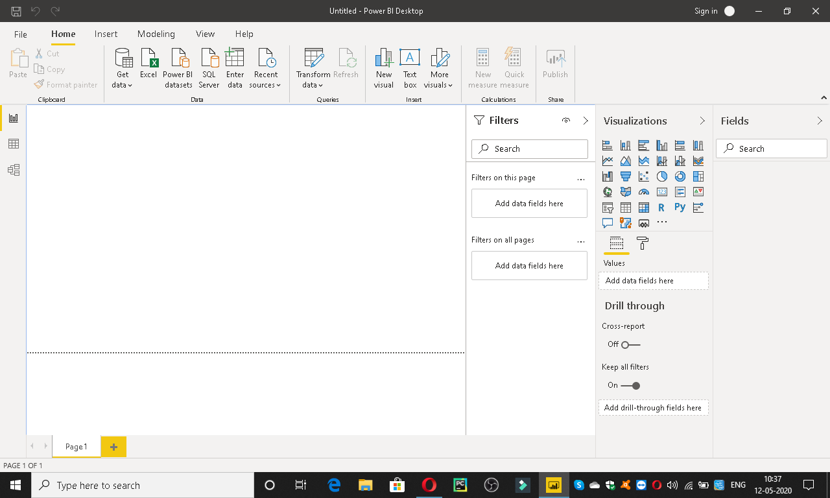

**DataView**

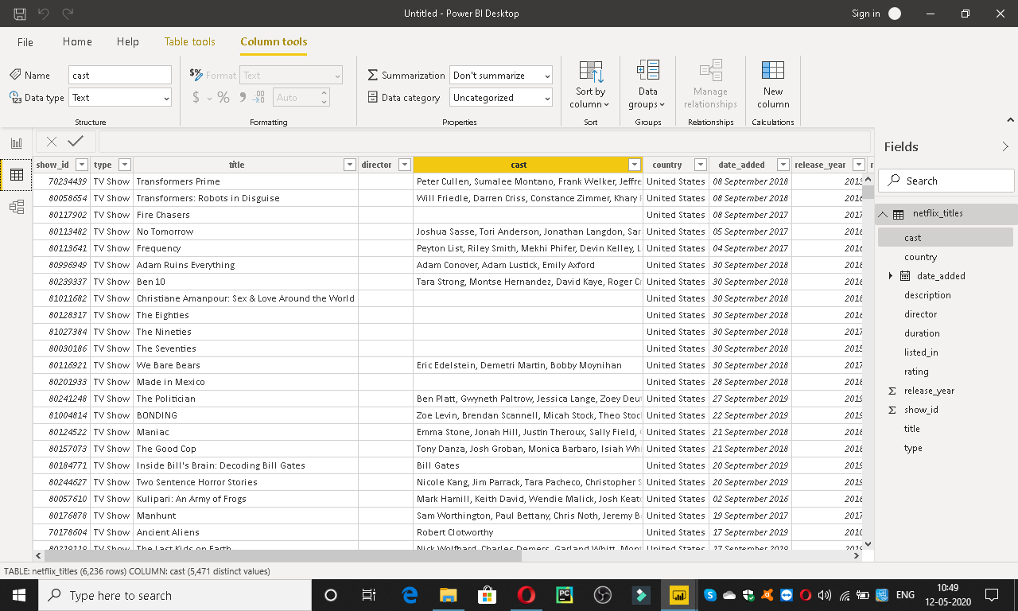

**ModelView**

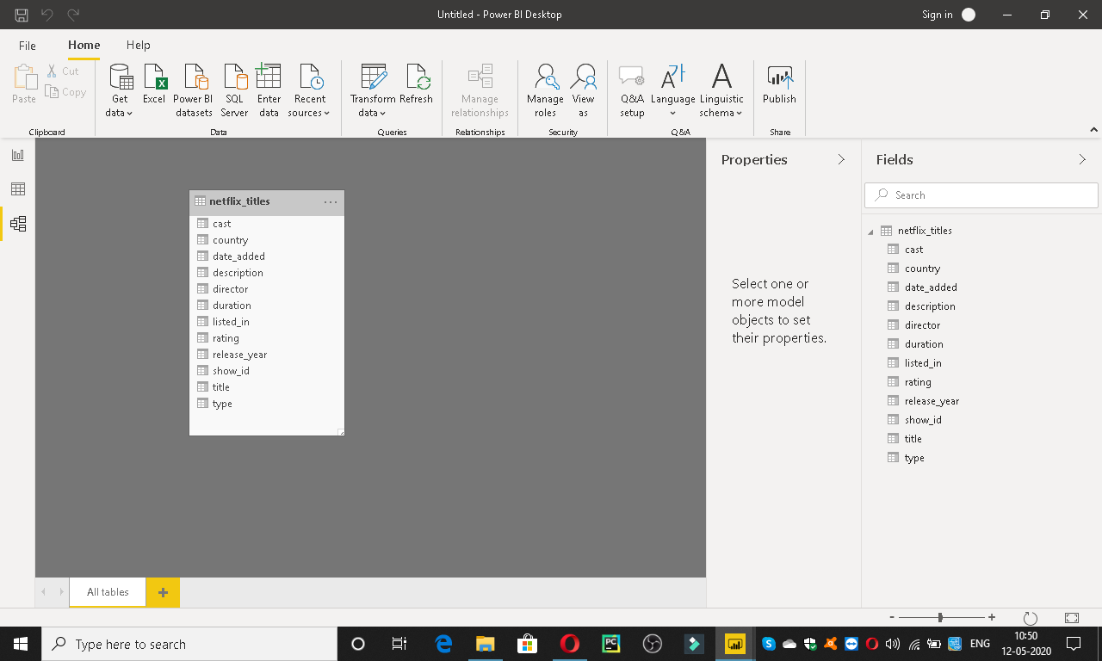

**Power Query Editior**

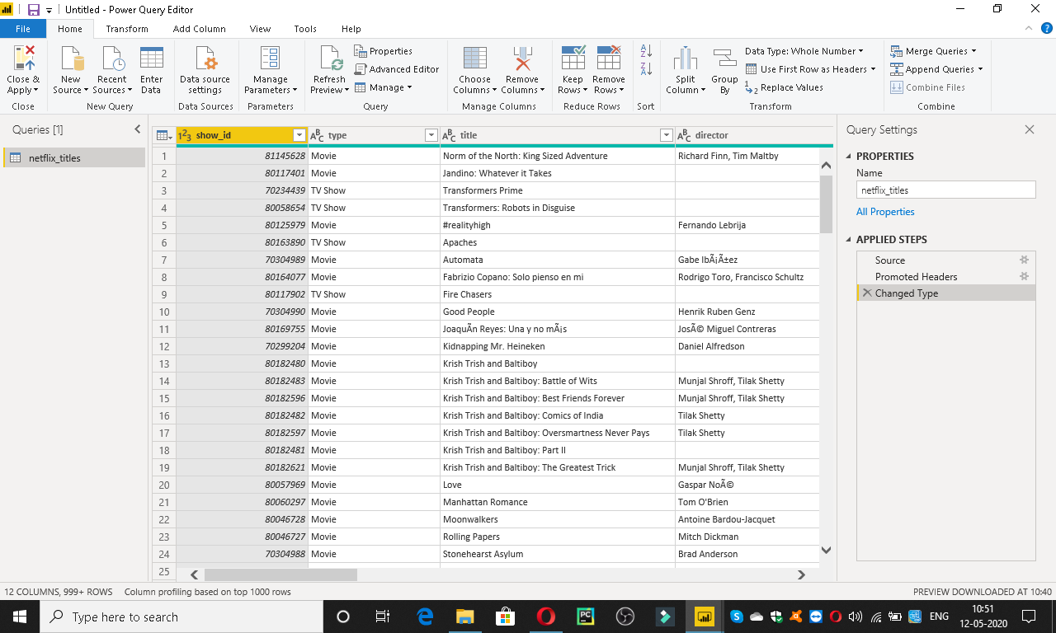

**Advanced Editior**

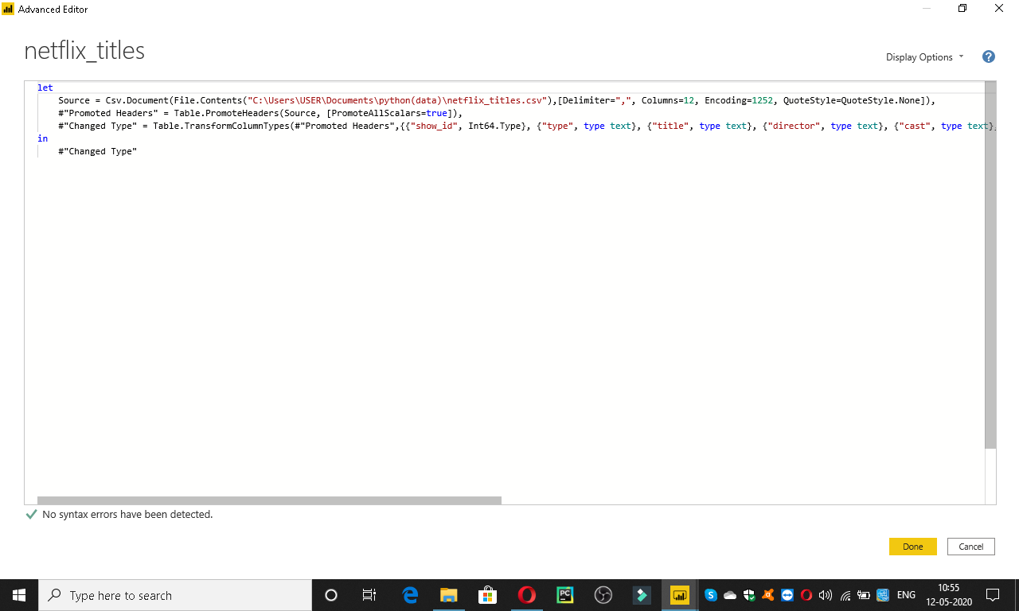

* **Here Details of the PowerBi along with their price’s**

**Power BI has three pricing plans:**

* **Power BI Desktop: This offering is free to any single user and includes data cleaning and preparation, custom visualizations and the ability to publish to the Power BI service.**
* **Power BI Pro: The Pro plan costs $9.99/user/month. It includes data collaboration, data governance, building dashboards with a 360-degree real-time view and the ability to publish reports anywhere. Users can try it a free trial for 60 days before purchasing the subscription.**
* **Power BI Premium: The Premium plan starts at $4,995 a month per dedicated cloud compute and storage resource.**